Boat individual tours

Get to know Belgrade from 2 rivers (Sava and Danube), during individual ride on 6 meters boat.

* Maximum 5 passengers.
* Possible guidance and route customization (must be agreed in advance)
* Best time for start is from 18:00

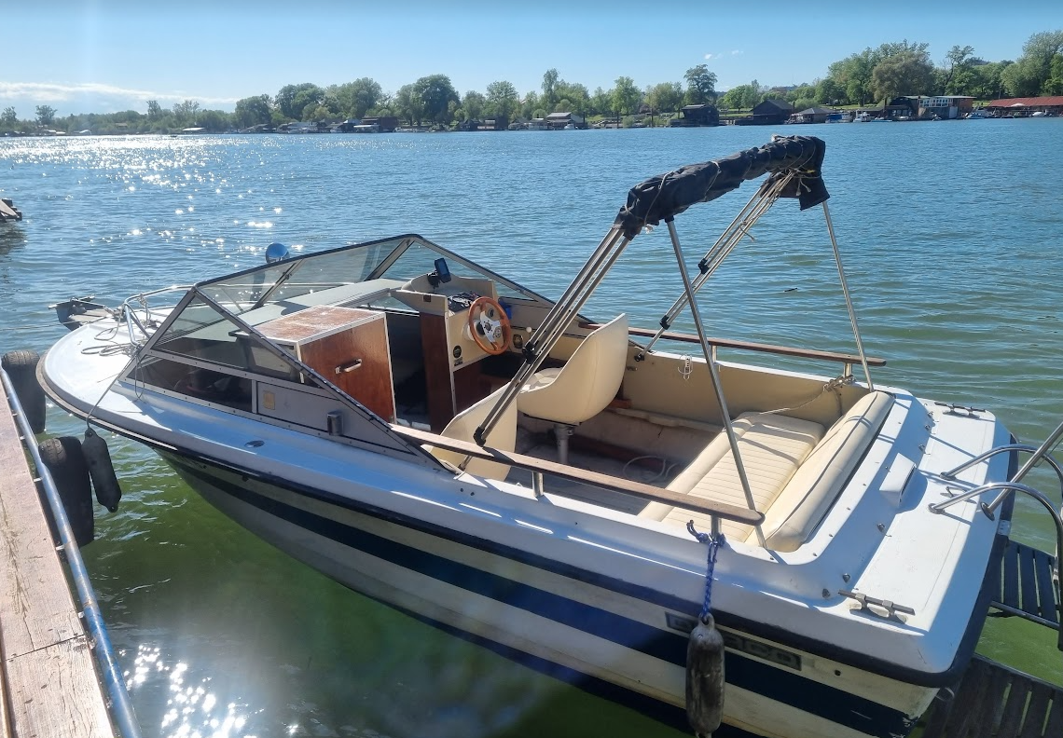

Prices (fuel and cold drinks included)

* 2 hr for 2 passengers – 150 EUR
* Each extra passenger cost extra 50 EUR
* Each hour on top of 2 hr costs extra 50 EUR

Standard route

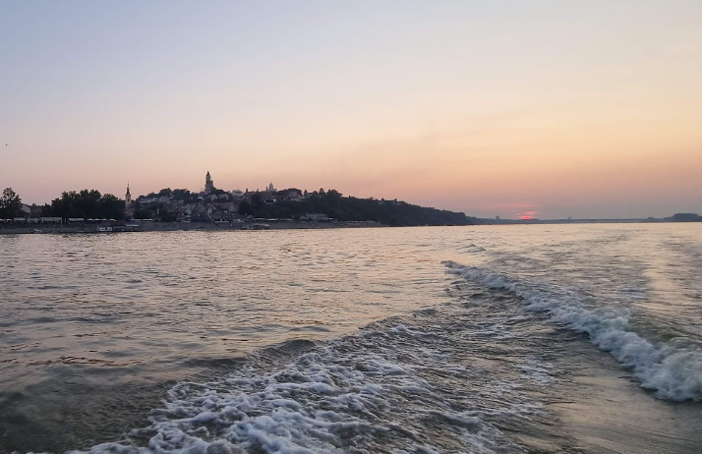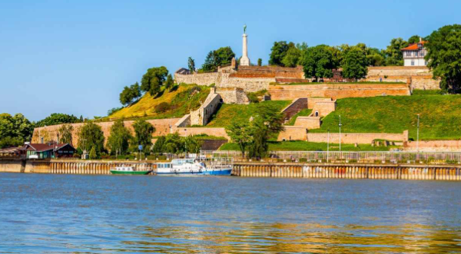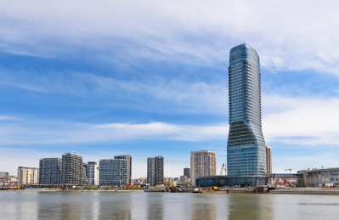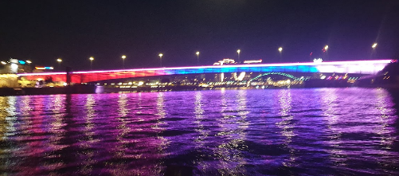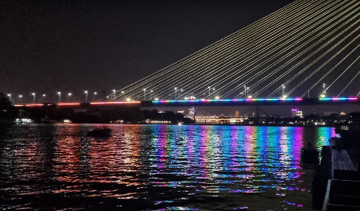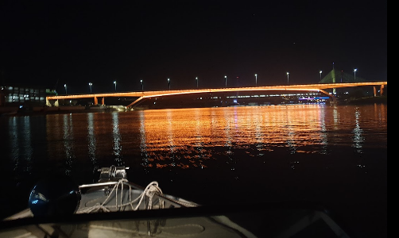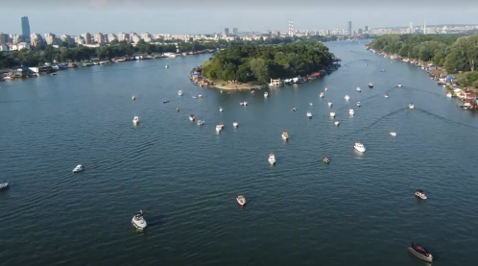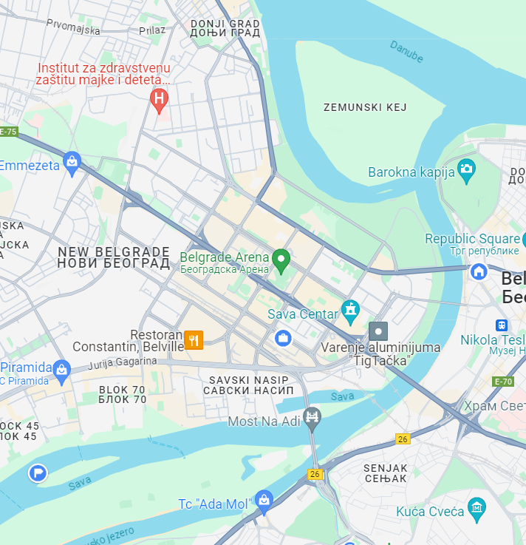

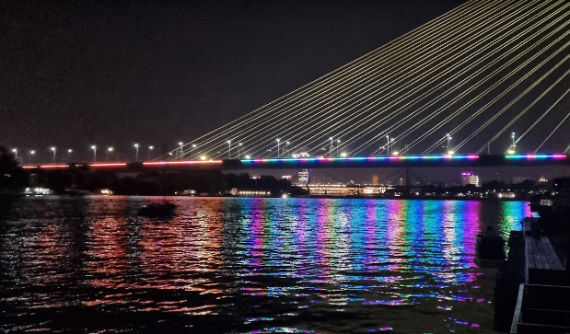

“Most na adi”

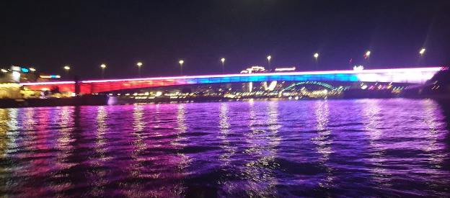

“Brankov bridge"

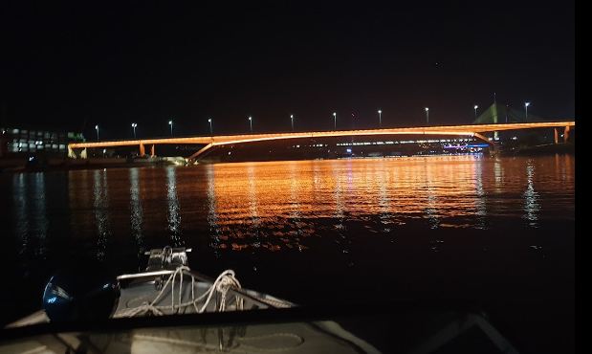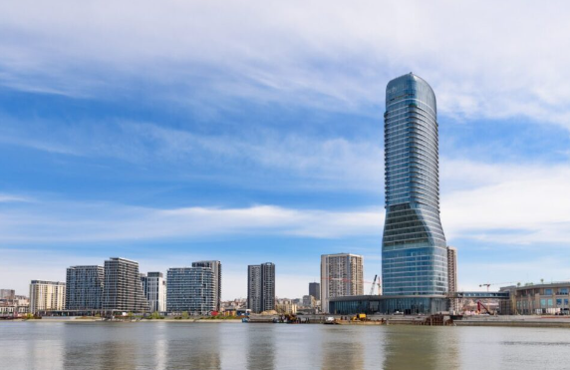

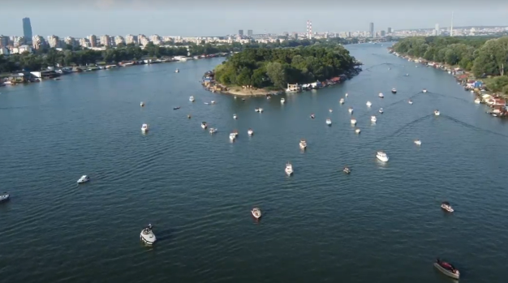 “Gazela bridge”



“Kalemegdan fortress”, confluence of Sava and Danube rivers.

“Ada međica” rever island, perfect place for summer sunsets.

Unique view on “Belgrade waterfront” and Belgrade panorama

Extra possibility to stop in one of many restaurants on water on customer request, price and time spent on meal is not included in general tour time.

